**Microsoft Office Live Meeting: FAQs**

1. **What is Microsoft Office Live Meeting?**

Live Meeting is a hosted web conferencing service that enables users to communicate and collaborate with anyone, anywhere- with just a PC, an internet connection, headphones and a mic.

1. **How do I get Live Meeting?**

Live Meeting 2007 can be downloaded from [here](http://office.microsoft.com/en-us/help/redir/XT010222792.aspx?CTT=5&origin=HA010173383).

1. **What are the system requirements for installing Live Meeting?**

|  |  |
| --- | --- |
| **Component** | **Requirement** |
| Display Resolution | Required: Super VGA 800x600 |
| Operating System | Windows 7, Windows Vista, Windows XP with SP2 or SP3, Windows Server 2003 with SP2 |
| Memory | Required: 256 MB RAM |
| Disk Space needed for installation | 125 MB |
| Bandwidth Requirements | 56 kbps for data, 80 kbps for voice, 350 kbps for video |
| Other Software | Microsoft Office PowerPoint 2002 or later presentation graphics program or Microsoft Office Standard Edition or Professional Edition (which includes PowerPoint software) to upload presentations.  Adobe Flash Player 9 or higher to view Flash content in the meeting. On Windows Vista, Adobe Flash Player 9.0.45 to view Flash content in the meeting.   Windows Media technologies player, version 9 or later (version is checked when the meeting client starts). |

1. **How do I attend the Live Meeting?**
2. Download and install the Live Meeting client on your computer.
3. You will be sent a URL for attending the Live Meeting. Click on the URL. Your client will start automatically and you will be able to join the meeting.
4. **I am unable to hear audio. What should I do?**
5. Click Voice and Video from the Live Meeting menu and click “Join Audio”.

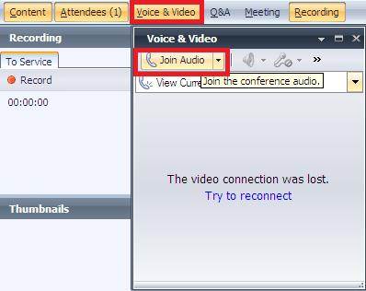

1. Once your audio is ok, you should be able to see the speaker enabled.

C:\Users\v-sbora\Pictures\Picture2.png

1. Check if the speaker is muted.

C:\Users\v-sbora\Pictures\Picture3.png

If it is, un-mute it. Also check if your computer’s speaker is working.

1. **How do I give feedback?**

For assistance/feedback to the Presenter, select the necessary option from the feedback drop-down menu in the toolbar.

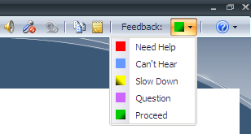

1. **How do I ask a question?**

Type a question in the “To ask the presenter a question, type it here and click Ask” field; then click the Ask button.

